**STUDY GUIDE: – River Valley Civilizations** Name: ______________________________

**Directions:** Your test is on _____________. STUDY!

**River Valley Civilizations**

|  |  |  |  |  |
| --- | --- | --- | --- | --- |
| How did people get food before the development of agriculture? | Another word for farming | The first steps to becoming civilized are to _______ down in permanent homes and to start _______. | | 4 Great River Valley Civilizations |
| All of the first civilizations developed near great | Two main reasons why rivers were important to early farming civilizations | | Why did river valleys have fertile soil? | What is irrigation? |

**Mesopotamia** (means ________________________________)

|  |  |  |  |
| --- | --- | --- | --- |
| 2 rivers of Mesopotamia | The arc-shaped area of land with rich soil where many of the first civilizations began | 1st civilization in Mesopotamia (They also invented the first writing!) | First known written language |
| Great Babylonian king | 1st set of laws written down | Group best known for their iron weapons and chariots | Group best known for their fierce and organized soldiers |
| Civilization that built ships and sailed all around the Mediterranean Sea to trade | The Phoenicians created the world’s first | How did the Phoenician alphabet spread? | Religious temples in Mesopotamia  Type of religion the Sumerians had |

**Egypt**

|  |  |  |  |
| --- | --- | --- | --- |
| The first pharaoh who united Upper and Lower Egypt | What protected Egypt from invaders | Egyptian kings were called  Define monarchy | Type of government in which a series of rulers come from the same family |
| Period in which the pyramids were built  Period when Egypt had the most glory and power | Group that invaded and took over Egypt during the Middle Kingdom | Type of religion the Egyptians practiced | Define polytheism  Define monotheism |
| They made mummies to preserve bodies for the | Purpose for building the great pyramids | Why did the Egyptians bury their dead with items such as food, treasure, and weapons? | Ancient Egyptian writing |
| What is papyrus?  What is a scribe? | Continent that Egypt is on  Climate in Egypt | Significance of the Rosetta Stone | River that contributed to the development of Egypt |

**Indus Valley**

|  |  |  |  |  |
| --- | --- | --- | --- | --- |
| Major river in India | The first civilization in the Indus Valley | Two well-planned cities of ancient India | They invaded the Indus Valley and took over | Writing system that began in ancient India |
| People divided into groups based on their social standing | How could you move to a higher level in this system? | Major religion that started in India | The term for when a person dies and their soul is reborn into a different body | Hinduism is a polytheistic religion. Define polytheism |

**China**

|  |  |  |  |  |
| --- | --- | --- | --- | --- |
| China’s major rivers | Like China, what other civilization had dynasties? | Dynasty that unified ancient China | How did Emperor Qin Shi Huangdi unify China | Purpose of the terra-cotta soldiers |
| What is the barter system? | Chinese writing developed from these symbols | What are oracle bones? | China’s most important export | Purpose of the Great Wall of China |

**Inventions/Achievements/Contributions – List as many as possible for each civilization!**

Know at least one invention/achievement/contribution for EACH civilization for the constructed response!

|  |  |  |  |
| --- | --- | --- | --- |
| **Mesopotamia** | **Egypt** | **India** | **China** |

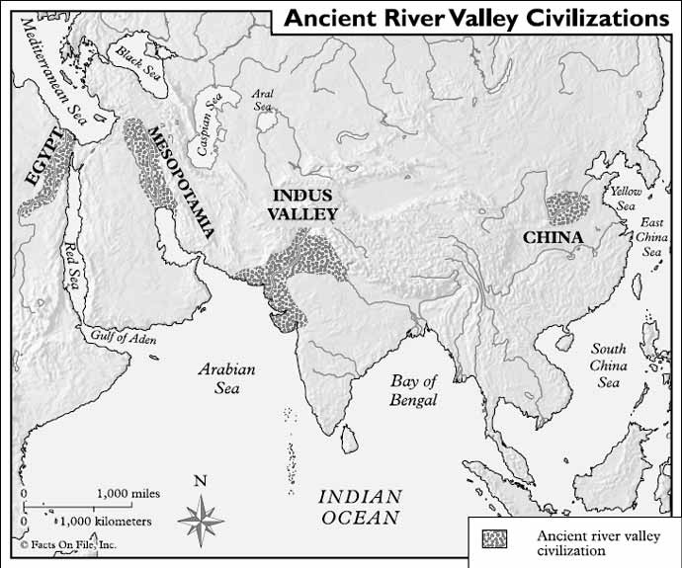

**Civilizations**

______ Mesopotamia

______ Egypt

______ India/Harappan

______ China

**MATCHING –** Match each civilization with the river(s) that supported it.

**Rivers**

1. Huang He
2. Tigris and Euphrates
3. Nile
4. Indus

**Study the map – You need to know the locations of each of these civilizations!**